**Work Breakdown Structure**

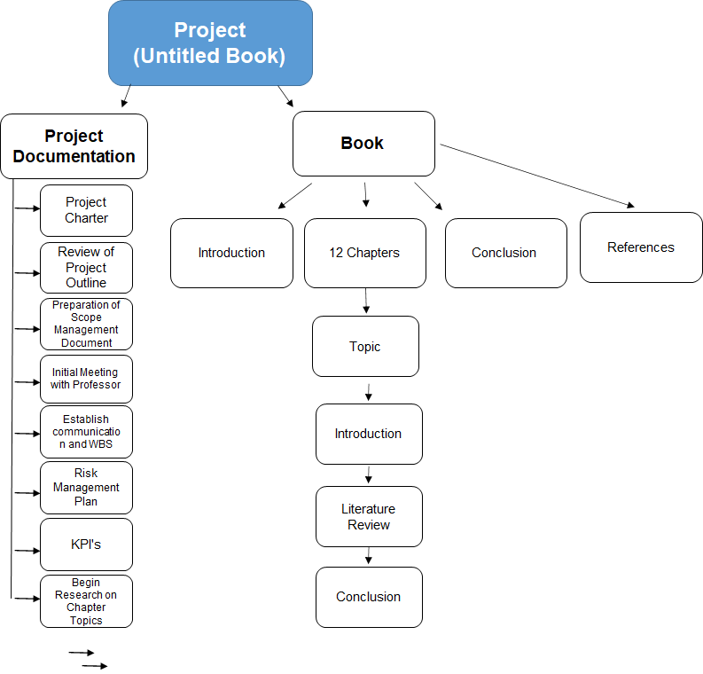

**Dependency Matrix**

|  |  |  |  |  |  |
| --- | --- | --- | --- | --- | --- |
|  |  |  | **Name** | **Duration (days)** | **Dependency** |
| **Project documentation** |  |  |  |  |  |
|  |  | Project Charter | A | 4 |  |
|  |  | Review of Project outline | B | 1 |  |
|  |  | Preparation of Scope Management Document | C | 5 | A, B |
|  |  | Initial Meeting with Professor | D | 1 | B, C |
|  |  | Establish communication and WBS | E | 7 | C, D |
|  |  | Risk Management Plan | F | 7 | E |
|  |  | KPI’s (Align to targets, credible sources, etc.) | G | 7 | F |
|  |  | Begin Research on Chapter Topics | H |  | C |
| **Book** |  |  |  |  |  |
|  | Introduction |  | I | 7 | H |
|  | 12 Chapters |  | J |  | M, K |
|  |  | Topic | K | 1 | H |
|  |  | Introduction | L | 4 | K |
|  |  | Literature Review | M | 5 | H, K |
|  |  | Conclusion | N | 4 | K, L, M |
|  | Conclusion |  | O | 7 | I, J |